COMMUNITY FIRST PLAN FOR LEABRIDGE WARD

Maps of Leabridge Ward
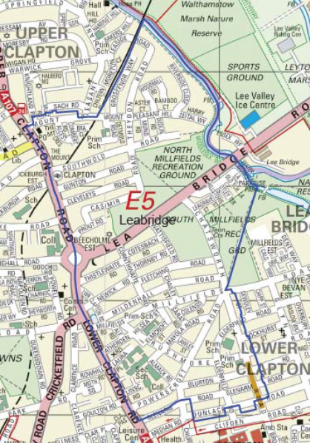
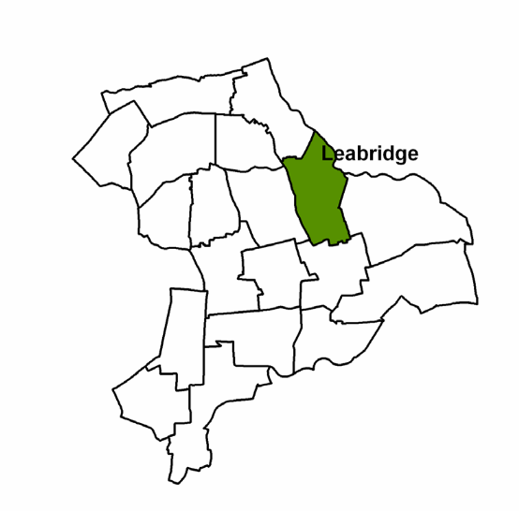

http://www.hackney.gov.uk/Assets/Documents/leabridge-ward-profile.pdf

Leabridge Ward Community First Panel

Ian Rathbone : Councillor for Leabridge Ward
Julia Lafferty : The Hackney Society
Monica Blake : The Hackney Society
Ruth Gray: Clapton Salvation Army
Euan Mills : Chatsworth Road Neighbourhood Forum
Conny Schmidt: Clapton
Jean John: Clapton

The Panel Partner is Clapton Pond Neighbourhood Action Group (CPNAG).

The priorities for the Leabridge Ward Community First Panel are:
· To help promote the local economy
· Improve the quality of community life
· Bring different communities within the ward together
· Support preservation of our local heritage

The key aims are:
- Socialbility
- Diversity
- Accessibility
- Independence
- Sustainability
(The definition and expanded explanation of these is included later in this document.
http://www.chatsworthroade5.co.uk/planning/neighbourhood-plan/)

Information on Leabridge Ward:

This overview of the ward sets the scene for the area within which the Leabridge Community First Panel is working.

Leabridge Ward lies on the North-Eastern side of Hackney. At the time of the 2011 Census its 106 hectares were home to 14,039 people, up from 9,857 in 2001.

(The following statistics are again taken from Hackney http://www.hackney.gov.uk/Assets/Documents/leabridge-ward-profile.pdf)

Age profile:

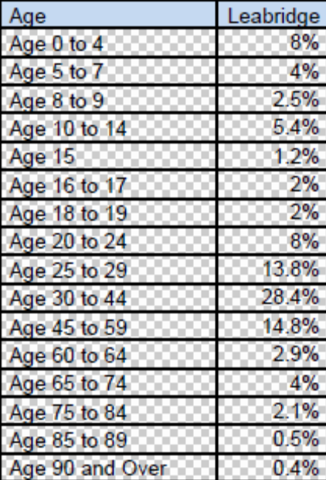

Ethnicity
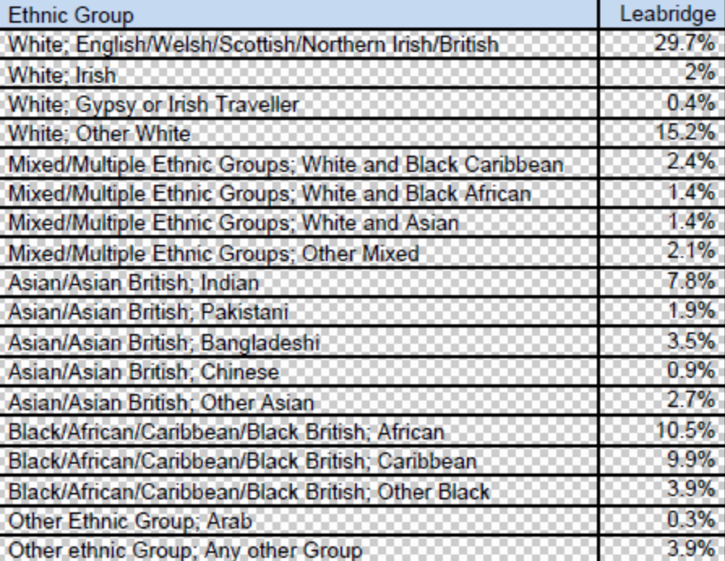

Religion

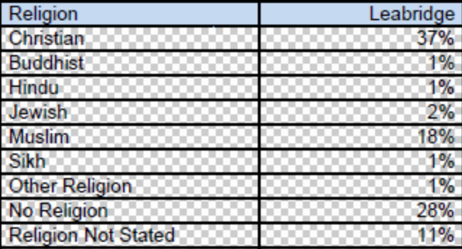

Household composition

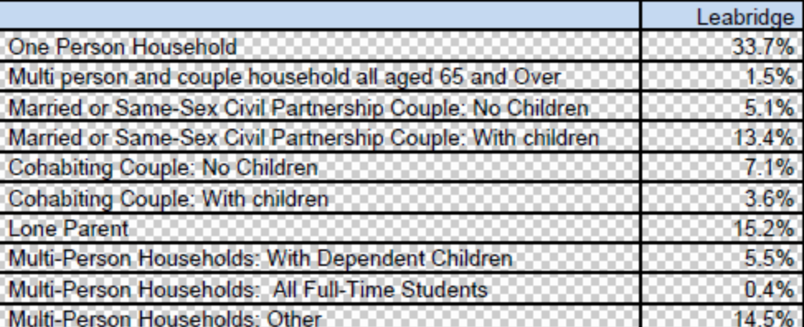

Housing Tenure

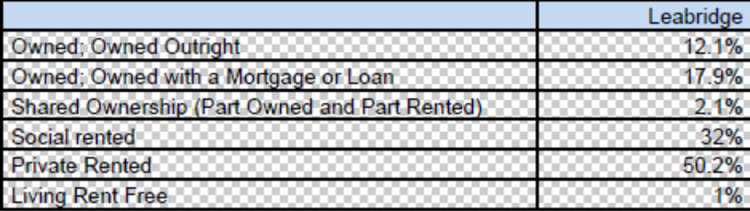
Half of the ward’s households rented their homes from a private landlord in 2011. In 2001 this was 18%.

Social Housing Estates

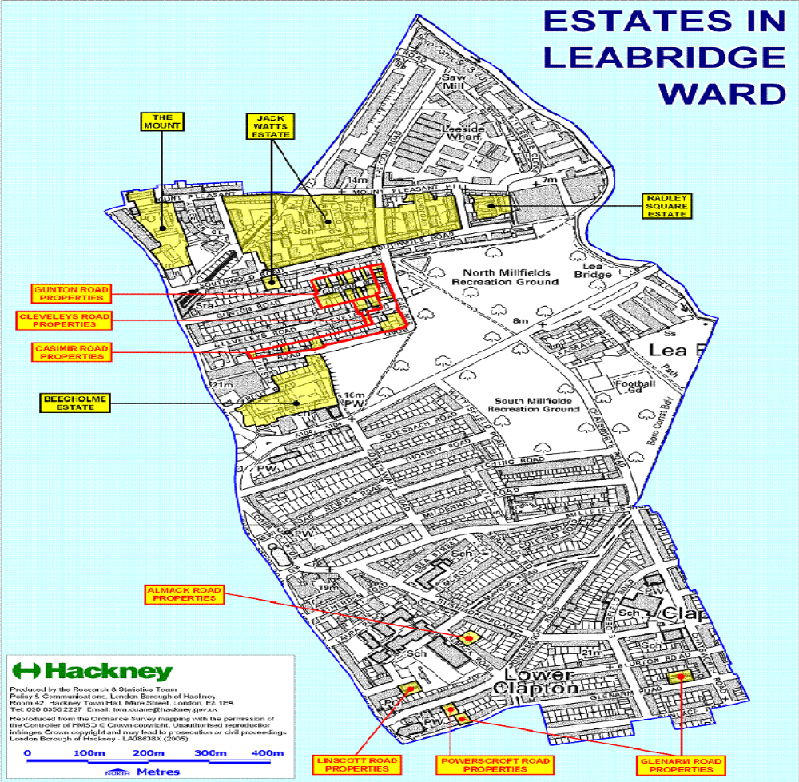

This map shows social housing estates in Leabridge Ward. However, over a quarter of Hackney Homes properties are owned by leaseholders, who have purchased their homes from the Council. They either live in these properties themselves or rent them to private tenants. Some two percent of households in Leabridge Ward live in Shared Ownership properties. These are part-owned by the resident and part owned by a housing association.

Employment

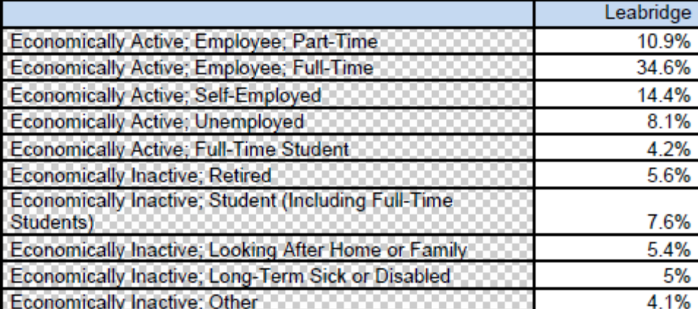

Unemployment is higher than the borough (Hackney) average, but there are proportionally more people working in managerial and professional jobs In 2011 59% of adults aged 74 and under were in work in Leabridge, up from 52% in 2001.

Health:

Leabridge residents have generally poorer health than the average for the borough of Hackney which is where it is located.
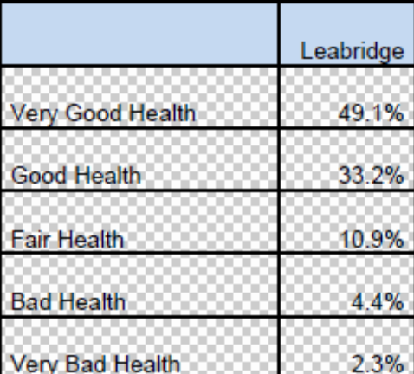

Crime:

Crime in Leabridge fell compared with the previous year.

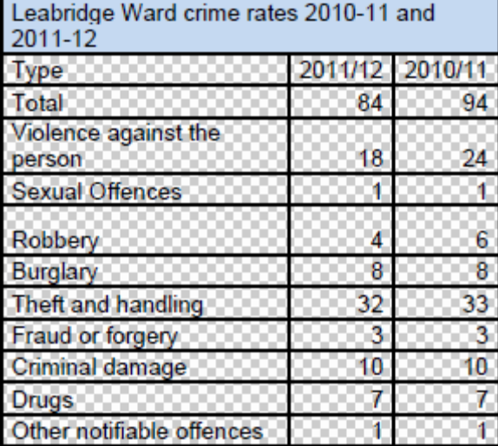
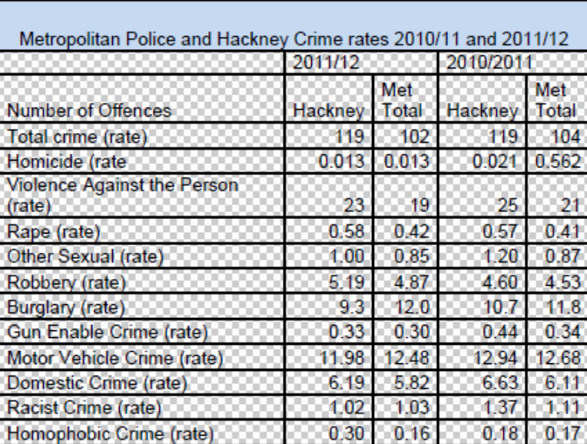

Deprivation:

The whole of the information recorded by Hackney council has been included under this section as it helps to give an overall picture of deprivation.

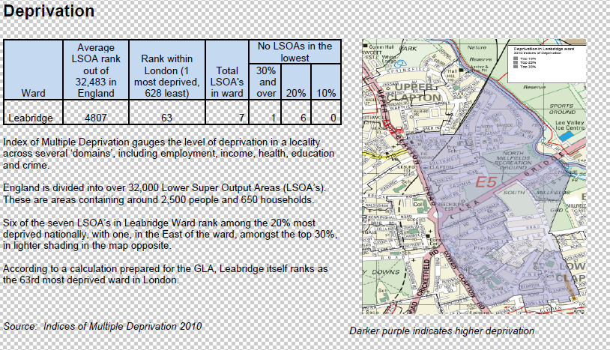

Further key information:

In January 2011a significant community research project was undertaken by ‘Chatsworth Road Neighbourhood Forum’ This area of Hackney covers half of the area defined as Leabridge Ward with the other half compromising mainly housing estates. (For detailed information on their entire project please see: http://www.chatsworthroade5.co.uk/planning/neighbourhood-plan/)
The Chatsworth Road neighbourhood Forum embarked on a project to identify the common aspirations that local people have for the area. In order to do this they had approximately 300 local residents fill out surveys; 14 in-depth case study interviews with a hand-picked diverse range of residents; 60% of local businesses give their views via a trader specific survey; 14 local community group representatives, including religious groups, tenants organisations and elderly and youth clubs, local councillors and police; all took part in the project with students from the City Academy school considering the future of the area.

At the end of this project the work was consolidate and distilled into five key aspirations that it was felt best reflected local people’s values about the area, these are set out below:

1. Sociable
There is more to a great neighbourhood than just people living in the same area. We want a neighbourhood that has a strong sense of community, a place rich in social capital. A neighbourhood where we recognise people who use the same shops, streets and spaces that we do, where we often bump into people we know, and can go to places where we can meet others who might have the same interests as us.

2. Diverse
We want a neighbourhood defined by its diverse mix of people, rather than any single dominant group. A place where people of all ages, incomes and creeds live and work side by side, where we are exposed to different cultures, tastes and beliefs to our own but still feel at home. A place that is open to incomers but values its longer-term residents. We need to encourage this diversity and nurture shops, provide homes and build workplaces that can serve our diverse community.

3. Accessible
We want to live in a neighbourhood that is easy to get around, whether walking, cycling, driving or in public transport. A place where it is safe and attractive to walk to shops, parks and schools, where the less abled feel they can get around with as much ease as the abled, where you can cycle without feeling intimidated by motor vehicles, but where you can easily drive through to get to go farther afield. We need a neighbourhood with a simple and legible network of streets, where the burden of traffic is shared equally. Streets that can accommodate a variety of users whilst prioritising the most vulnerable.

4. Independent
We want a neighbourhood with a healthy and resilient local economy, a place where money remains in the community and profit is measured not solely in pounds and pence. A place not dependent on any single company for goods, services or employment. A place that supports a diverse range of local small and medium-sized business, and provides a nurturing environment where new businesses can flourish. A place that attracts talented, creative and the entrepreneurial people to live and to work.

5. Sustainable
We want a neighbourhood that uses resources wisely and actively minimises its ecological footprint. A neighbourhood where all waste is recycled or re-used; where walking and cycling are the primary modes of transport; where the energy we consume is produced in a sustainable manner and all buildings use it efficiently; and with places to grow our own food.

Conclusion:

As this research was undertaken and connected with a cross section of people living within the Leabridge Ward the Community First Panel adopt these aspirations and the explanations of these as the foundation for its community plan.
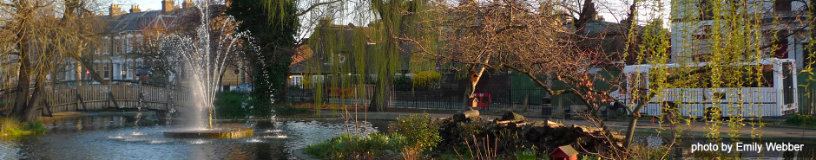

Clapton Pond located within Leabidge Ward.

